XMUM Collaborates with Sabah Tshung Tsin Secondary School on Interdisciplinary Science Camp
Published on June 16, 2023
China-ASEAN College of Marine SciencesDepartment of Physics
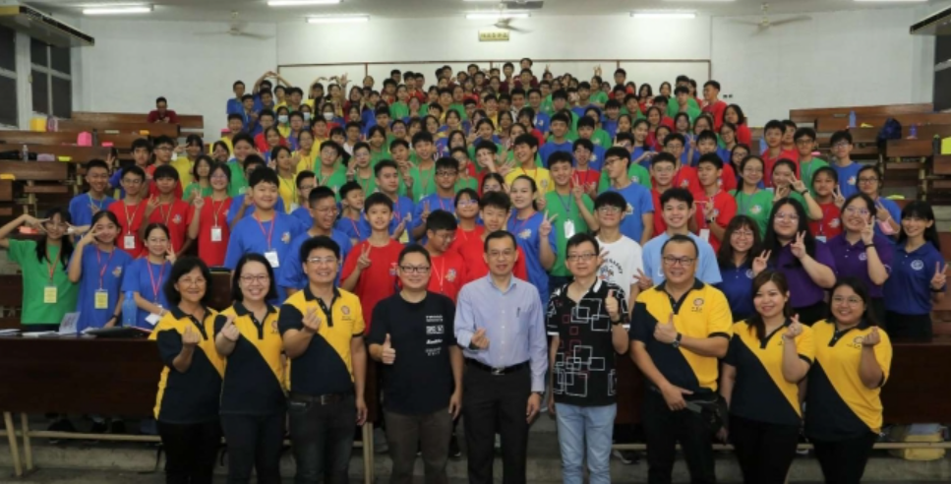
Group photo. Center: Principal of Tshung Tsin Secondary School, Dr. Chung Chin Hing.
Left: Dr. Teoh Wong Wooi, Mr. Lim Boon Kiat. Right: Dr. Chung Fei Fang, Mr. Lai Kok Fu.
From 31 May to 2 June 2023, Department of Physics and China-ASEAN College of Marine Sciences, Xiamen University Malaysia, collaborated to support the First Interdisciplinary Science Camp of Sabah Tshung Tsin Secondary School.
Dr. Teoh Hong Wooi from China-ASEAN College of Marine Sciences gave a talk on the importance of Marine Science. His team, consisting Nina Ho Ann Jin, Tay Yii Jing, and Teh Seok Qi, guided the students in printing a ﬁsh using a traditional method from Japan, named Gyotaku.
Representating Department of Physics were Dr. Chung Fei Fang and two students, Liew Dek Hao and Zhang Weibao. In the talk “Games of Fractals”, Dr. Chung used computer games to engage audience into the world of physics. During the hands-on activity, Liew Dek Hao and Zhang Weibao demonstrated the students how a complex structure emerges by repeating a simple rule on paper cutting.
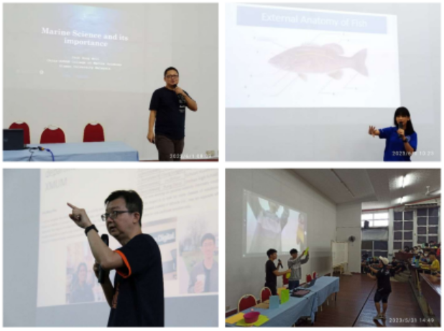
Dr. Teoh Wong Wooi, Ms. Nina Ho Ann Jin, Dr. Chung Fei Fang and Liew Dek Hao, Zhang Weibao during the event
Tay Yii Jing: "It was a enjoyable and great experience to join the CSI STEAM Camp, especially since it is my first time joining a Science Camp. I was happy to share some of my experiences as a Marine Biotechnology student, and had a fun time assisting the students in the gyotaku activities. It was a pleasure to meet everyone & thank you for giving me this opportunity!"
Teh Seok Qi: "It was a very special experience to join CSI STEAM science camp as a teaching assistant. Sharing my university experiences as a Marine Biotechnology person with Tshung Tshin High School students reminded me of all the fun memories thourought these years at XMUM. I was also amazed by the art and crafts skill students showed during the gyotaku sessions. A big appreciation to everyone who made this camp successful!"
Liew Dek Hao: "The CSI Steam camp at Sabah Tshung Tsin Secondary School was an amazing experience, which gave me an opportunity to share my knowledge with enthusiastic students. The school provided a lively setting that encouraged learning and creativity. Seeing the students' excitement during the hands-on project and workshop made me realize the importance of nurturing their curiosity and passion for STEAM subjects. This camp reminded me of education’s impact on young minds and reinforced my dedication to empowering students. Overall, I feel incredibly lucky to have been chosen to be a part of this event. I would like to express my heartfelt gratitude to the Department of Physics at XMUM for giving me the incredible opportunity."
Zhang Weibao: "This is my ﬁrst time visiting Sabah. When the plane landed, I was already captivated by the unique and beautiful natural landscape. The students participated in the activities and answered questions actively, and their eyes were ﬁlled with a thirst for knowledge and curiosity about science. The teachers and students from CSI organized the activities with careful planning, making the whole event smooth and successful. It was an unforgettable experience to be a teaching assistant and I really cherish the friends I made there. Sincerely hope to see them again!"
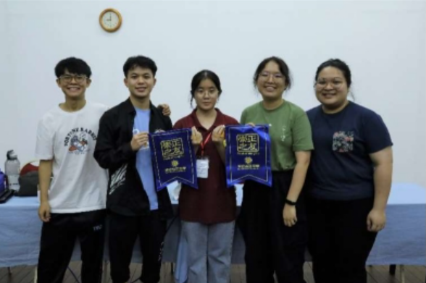
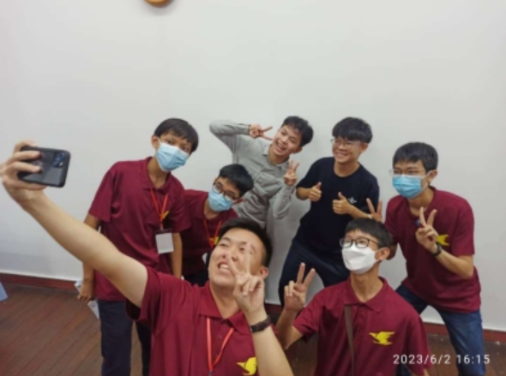
Liew Dek Hao, Zhang Weibao, Teh Seok Qi, Tay Yii Jing are popular among the students

